Chapter 19, Problem 16.

For the circuit in Fig.19.77, at w = 2 rad/s, z₁₁ = 10 Ω, z₁₂ = z₂₁ = j6 Ω, z₂₂ = 4 Ω.
Obtain the Thèvenin equivalent circuit at terminals a-b and calculate v_{o}.

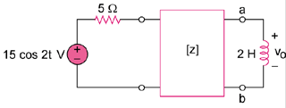

Figure 19.77
For Prob. 19.16.

